# **LAB REPORT # 01**



**Spring 2025**

**CSE-303L Data Communication and Networks Lab**

# Submitted by: **Naveed Ahmad**

Registration No.: **22PWCSE2165**

Class Section: **B**

“On my honor, as a student at the University of Engineering and Technology, I have neither given nor received unauthorized assistance on this academic work.”

Student Signature: ______________

Submitted to:

# **Dr. Yasir Saleem Afridi**

March 05, 2025

Department of Computer Systems Engineering

University of Engineering and Technology, Peshawar

**Gathering TCP/IP configuration information.**  
**Step 1:**  
Establish and verify connectivity to the Internet. This ensures the computer has an IP address.

**Step 2**:  
Use the Start menu to open the Command Prompt, an MS-DOS-like window. Press Start > Programs > Accessories > Command Prompt  
OR  
Start > Programs > Command Prompt.  
OR  
Press Start>Run Then type cmd.

The following figure shows the Command screen. Type ipconfig and press the Enter key. The spelling of ipconfig is critical while case is not. It is short for IP **Configuration.**

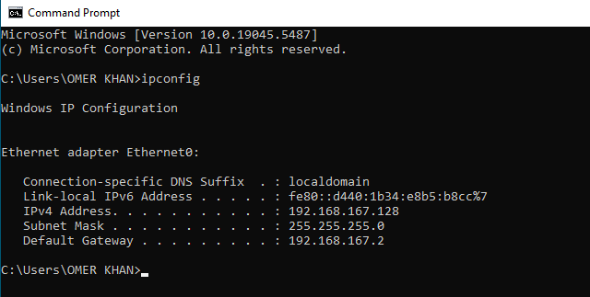

**Step 3:**

Record the following TCP/IP information for at least THREE computers.

|  |  |  |  |
| --- | --- | --- | --- |
|  | **Computer 1** | **Computer 2** | **Computer 3** |
| **IP Address** | 192.168.167.128 | 192.168.43.28 | 10.110.140.227 |
| **Subnet Mask** | 255.255.255.0 | 255. 255. 255.0 | 255.255.252.0 |
| **DNS Address** | 192.168.100.177  8.8.8.8 | 192.168.100.247 | 192.168.43.27 |
| **DHCP Address** | 192.168.100.153 | 192.168.43.27 | 192.168.10.1 |

**Step 4:**

Compare the TCP/IP configuration of this computer to others on the LAN. If this computer is on a LAN, compare the information of several machines.

| **Configuration** | **Computer 1** | **Computer 2** |
| --- | --- | --- |
| **IP Address** | 192.168.167.128 | 192.168.43.28 |
| **Subnet Mask** | 255.255.252.0 | 255.255.255.0 |
| **DNS Address** | 192.168.100.177 | 192.168.43.27 |
| **DHCP Address** | 192.168.100.153 | 192.168.10.1 |

**Q: Are there any similarities?**

**Ans:** As the two computers are connected to the same network so subnet mask, default gateway, DNS address and DHCP address are the same.

**Q: What is similar about the IP addresses?**

**Ans:** The network portion(bits) of the IP address is the same.

**Q: What is similar about the default gateways?**

**Ans:** the two computers are connected to the same network, so they have same default gateways.

**Step 5:**

**Check additional TCP/IP configuration information.**

To see detailed information, type ipconfig /all and press Enter. The figure shows the detailed IP configuration screen.

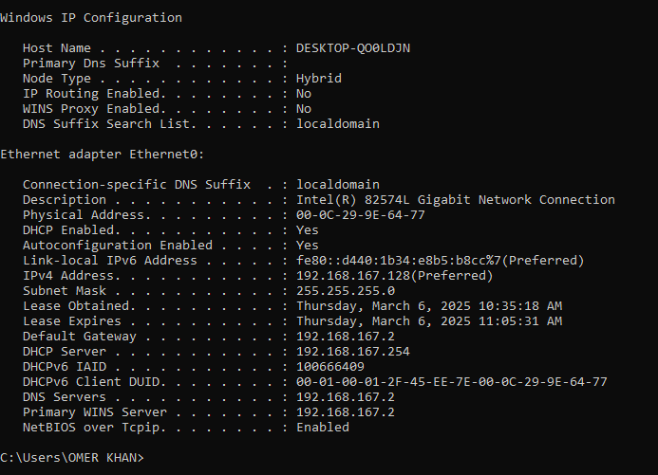

The host name, including the computer name should be displayed. Also, the DHCP server address, if used, and the date the IP lease starts and ends should be displayed. Look over the information. Entries for the DNS, used in name resolution servers, may also be present.

**Q: Notice the Physical Address (MAC) and the NIC model (Description).**

**Ans: Physical Address**: 00-0C-29-9E-64-77

**Description**: Intel(R) 82574L Gigabit Network Connection

**Q: Write down the IP addresses of any servers listed:**

**Ans: DHCP server**: 192.168.167.254

**DNS server**: 192.168.100.177 8.8.8.8

**Q: Write down the computer Host Name:**

**Ans:** DESKTOP-I16IA9O

**Q: Write down the Host Names of a couple other computers:**

**Ans:**

* Desktop -6VEC0PO
* DESKTOP-7KD6VLL

**Q: Do all the servers and workstations share the same network portion of the IP address as the student workstation?**

**Ans:** Not necessarily

It would not be unusual for some or all of the servers and workstations to be in another network. It means that the computer default gateway is going to forward requests to the other network.

## Step 6

Close the screen when finished examining network settings.

**Q: Based on observations, what can be deduced about the following results taken from three computers connected to one switch?**

Computer 1

IP Address: 10.110.140.227

Subnet Mask: 255.255.255.0

Default Gateway: 10.110.140.1

Computer 2

IP Address: 192.168.43.28

Subnet Mask: 255.255.255.0

Default Gateway: 10.110.140.1

Computer 3

IP Address: 10.110.140.227

Subnet Mask: 255.255.255.0

Default Gateway: 192.168.43.27

Q**: Should they be able to talk to each other?**

**Ans:**

As the two computers have same Subnet Mask and Default Gateway, that means that they are connected on a same network so **YES**, they can communicate with each other.

**Q: Are they all on the same network? Why or why not?**

**Ans:**

As their default gateway is the same, that means, the two computers are on the same network and the third computer based on these details, it's evident that are on different networks or subnets due to their IP addressing schemes, subnet masks, default gateways, DNS addresses, and DHCP-assigned addresses. Therefore, they are not on the same network.

**To flush the DNS resolver cache on a Windows computer, you can follow these steps:**

Open Command Prompt with administrative privileges. You can do this by searching for "Command Prompt" in the Start menu, right-clicking on it, and selecting "Run as administrator."

In the Command Prompt window, type the following command and press Enter:

